# MTSM’S

**COLLEGE OF INFORMATION TECHINOLOGY AND RESEARCH**

**(SOFTWARE DEVLOPMENT)**

**A**

**PROJECT REPORT**

**ON**

**“EDUCATIONAL WEBSITE”**

**Submitted to**

**Sandip University Nashik**

**In Partial Fulfillment of**

**B.VOC(Software Development)**

**By**

**Akshay Ganesh Adhav**

**For the year**

**2022-2023**

**Under the guidance of**

**Honey Andani**

|  |  |  |  |  |
| --- | --- | --- | --- | --- |
| **Chap** |  | **Details** | **Page No** | **Signature** |
| **1** |  | **Introduction** |  |  |
|  | 1.1 | Abstract |  |  |
|  | 1.2 | Scope of system |  |  |
|  | 1.3 | Operating Environment-Hardware & Software |  |  |
|  | 1.4 | Description of Technology Used |  |  |
| **2** |  | **Analysis & Design** |  |  |
|  | 2.1 | System Requirements (Functional and Non-Functional) |  |  |
|  | 2.2 | Snapshots of Projects |  |  |
| **3** |  | **Coding** |  |  |
|  | 3.1 | Code Snippets |  |  |
| **4** |  | **Proposed Enhancements** |  |  |

**Chapter-1 INTRODUCTION**

* 1. **Abstract:**
* Educational  website  will provide all information regarding our colleges.

 Now it is of vita thing in present scenario of any college where student can get all information before taking admission. This site provides the all information like student can easily get all information regarding their syllabus, especially for the training and placement since it is difficult to get the students informed during the campus so all the students can easily get information. There is also facility for the faculty members, they can easily give all the answer of student's question and can give their solution of problem

* This web site is having use of educational purpose.
* This gives a clear indication of importance of educational websites.

# Scope of system:

* It also helps in current all works related to college website.

* This web site is being developed for college and is intended to used by individuals with web access. Who are interested in obtaining bachelor’s degree in computer.
* This is also very useful for faculty and students of b.voc course
* This web sit is important to inform student about course information

# Operating Environment

* Software Requirement:

* Operating system: -Windows 10
* Browser: - Google chrome
* Protocol: -HTTP
* Web Server

* Hardware Requirement:
* Monitor
* Keyboard
* Ram
* Internet connection

# Brief Description of Technology:

## Technology

* + **Html5**

## HTML5 is a programming language whose acronym stands for Hyper Text Markup Language. It is a system that allows the modification of the appearance of web pages, as well as making adjustments to their appearance. It also used to structure and present content for the web.

* + **CSS**

## CSS is an extremely powerful style sheet language which is used to control the look and feel of the content written in HTML.

## Framework

* + **Bootstrap**
* Bootstrap describes itself powerful, extensible, and feature-packed frontend toolkit. In fact Bootstrap is the most popular CSS Framework for developing responsive and mobile-first websites.
* Next step is to include Bootstrap’s CSS file in the head section of the document by using a link to a CDN (Content Delivery Network).

## Tools

## VS Code

* Visual studio code is a code editor redefined and optimized for building and debugging modern web and cloud applications. Go beyond syntax highlighting and autocomplete with intelligence which provides smart completions based on variable types, function definitions and modules.

# Chapter-3 Analysis and Design

* 1. **System Requirements (Functional and Non-Functional requirements):**

## Functional Requirements

## The system provides all the information about the college in detail

## The system gives in detail description of our college infrastructure

## All the information about the faculty and labs are provided in department

## wise

## All the necessary information is rendered with proper images and flash

## Slides for better navigation

## Non-Functional requirements

**2.2 Snapshots of projects**

**First Screen:**

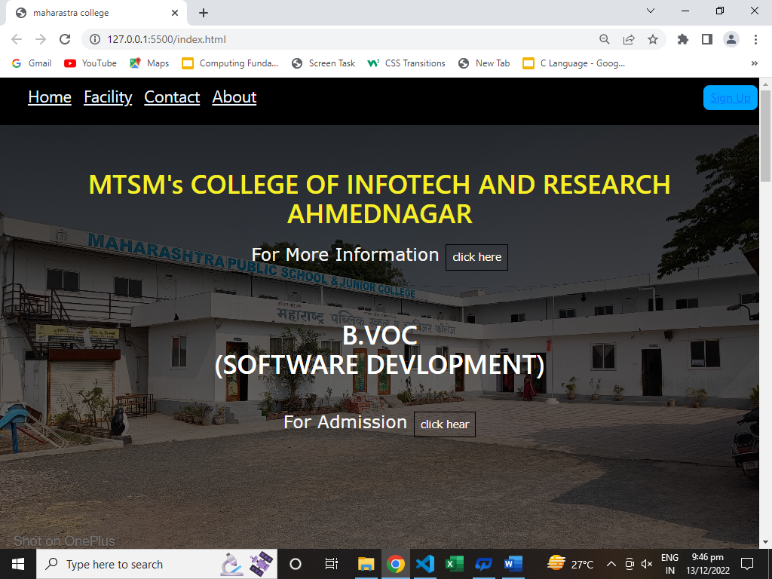

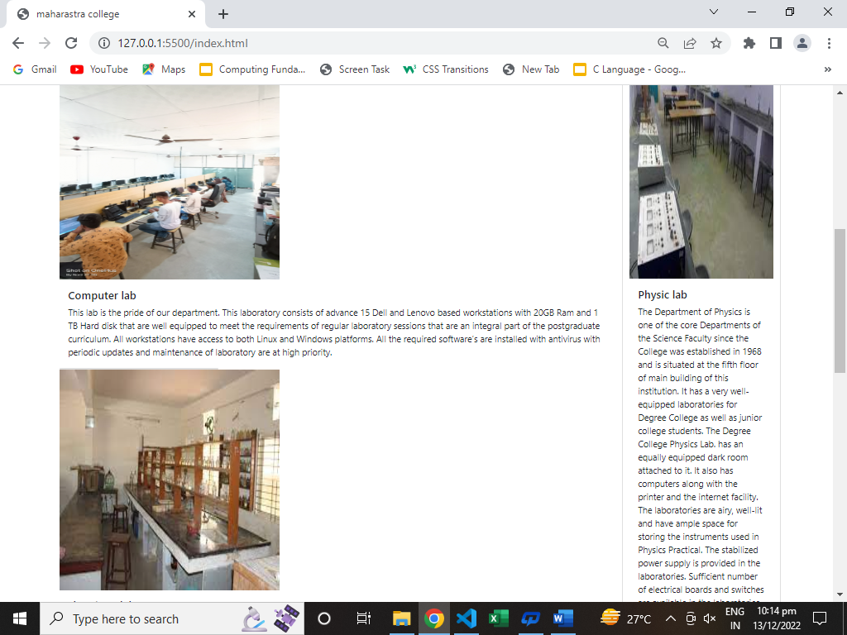

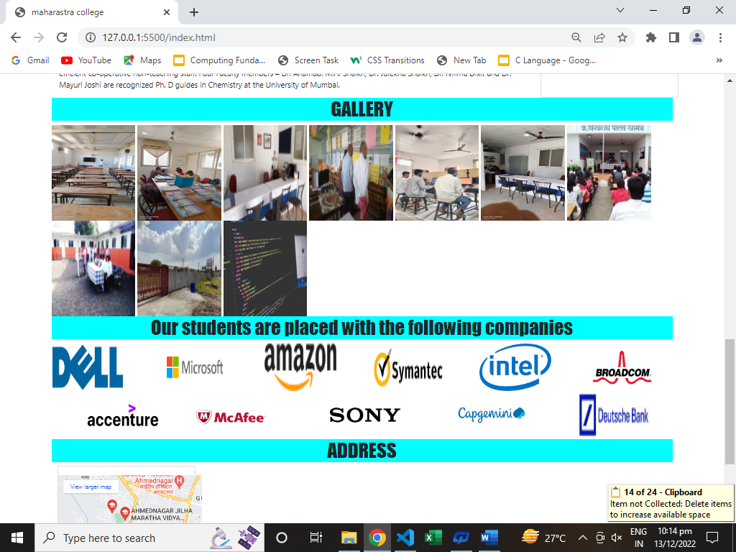

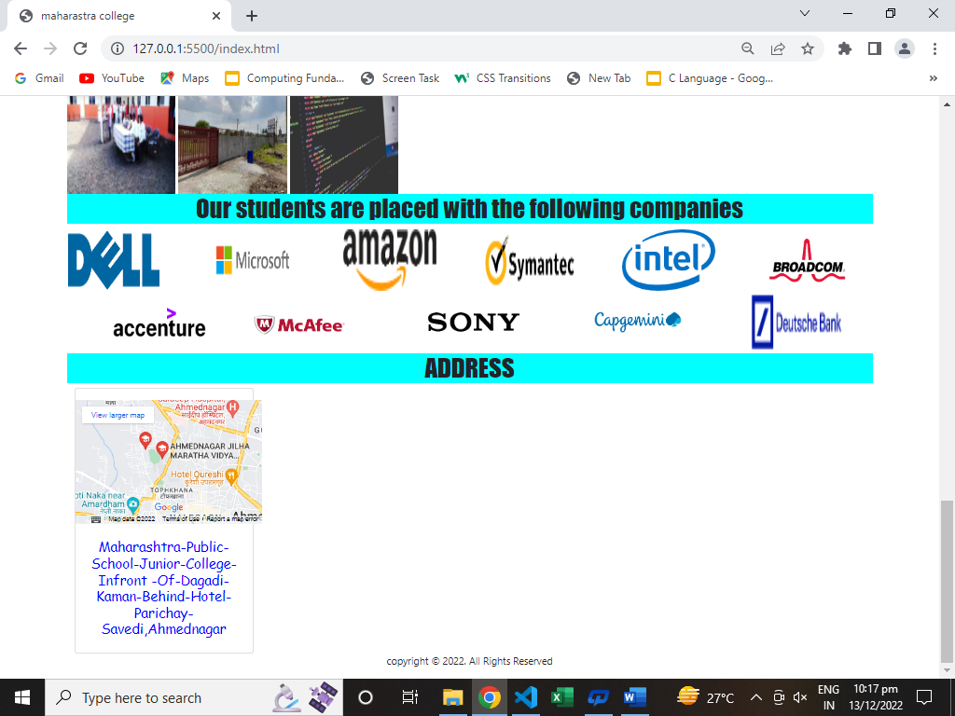

**Sign up page:**

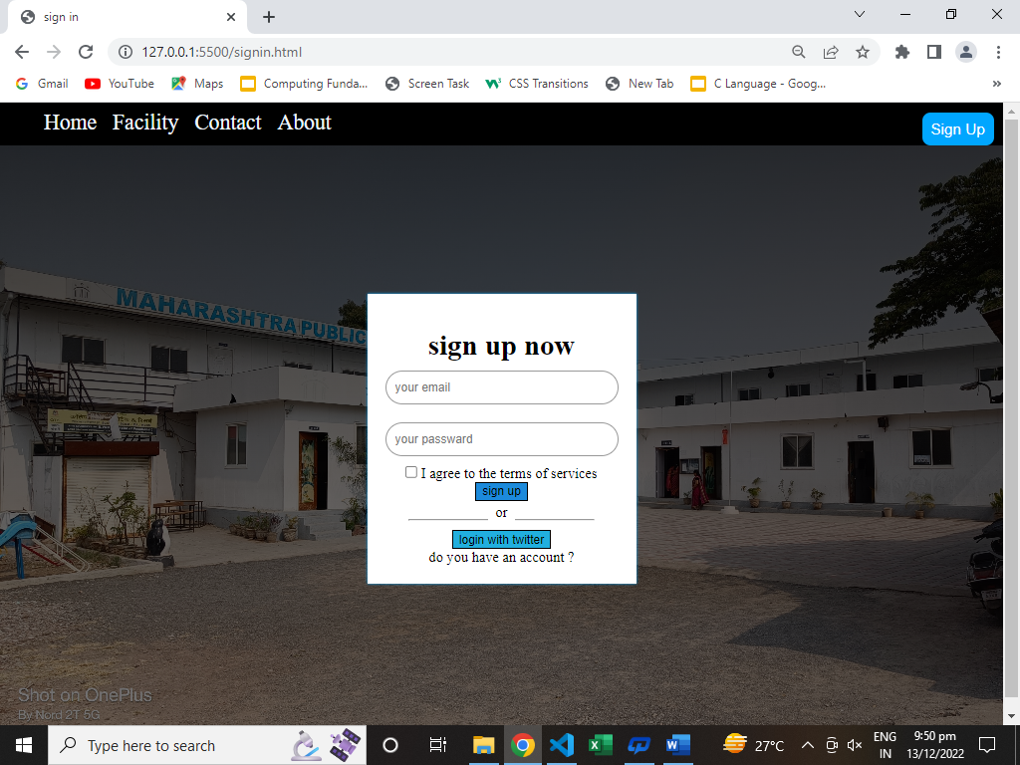

**Facility page:**

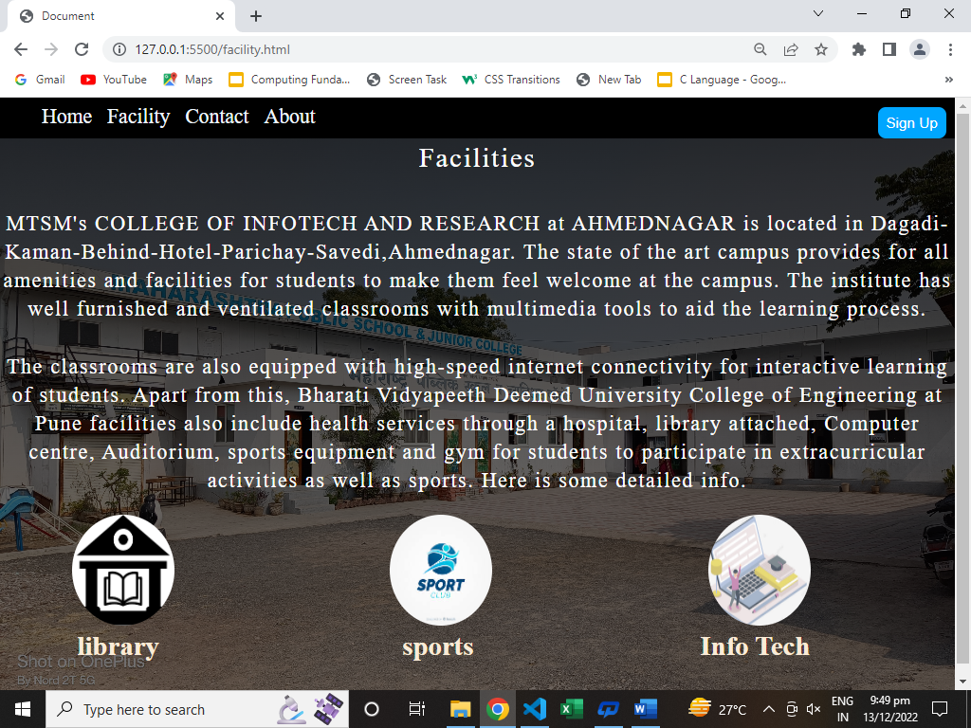

**Contact page:**

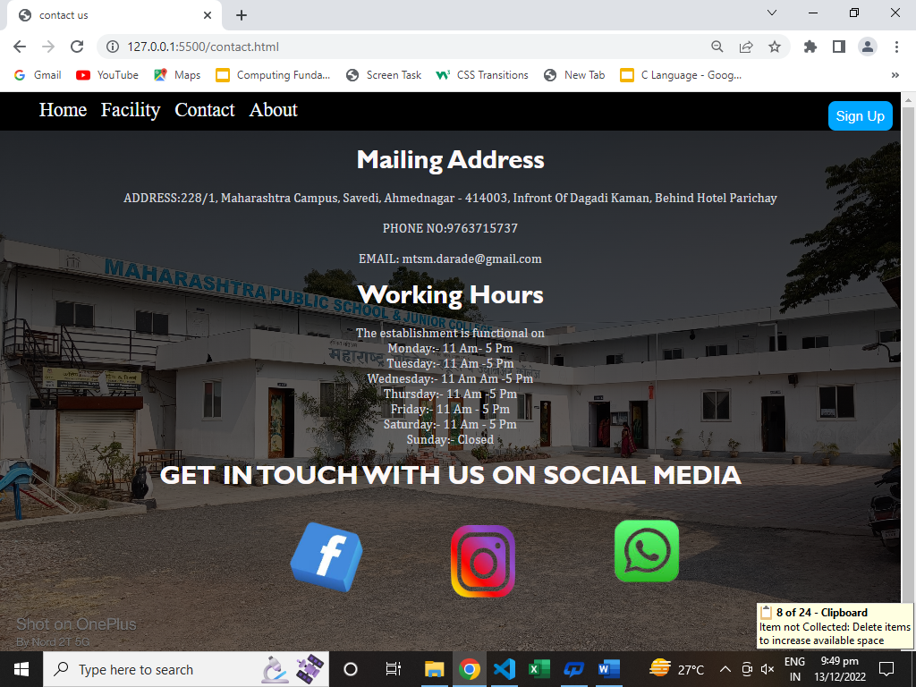

**About page:**

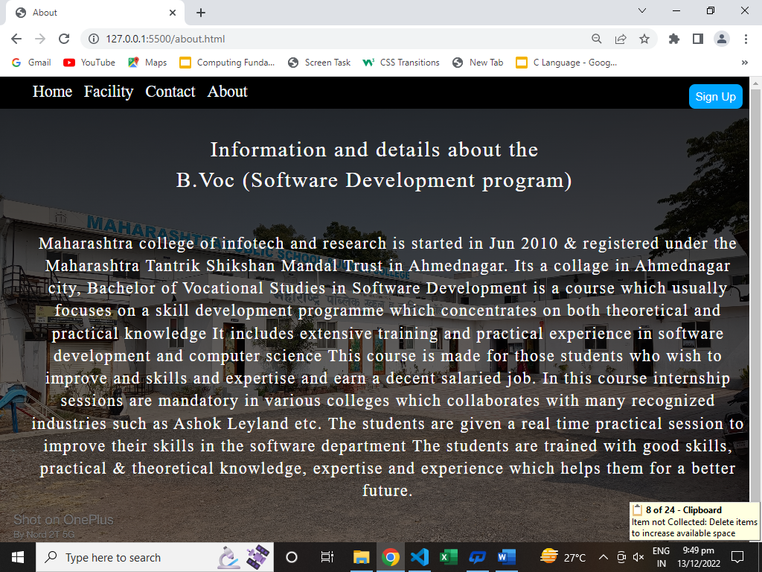

**Admission form page:**

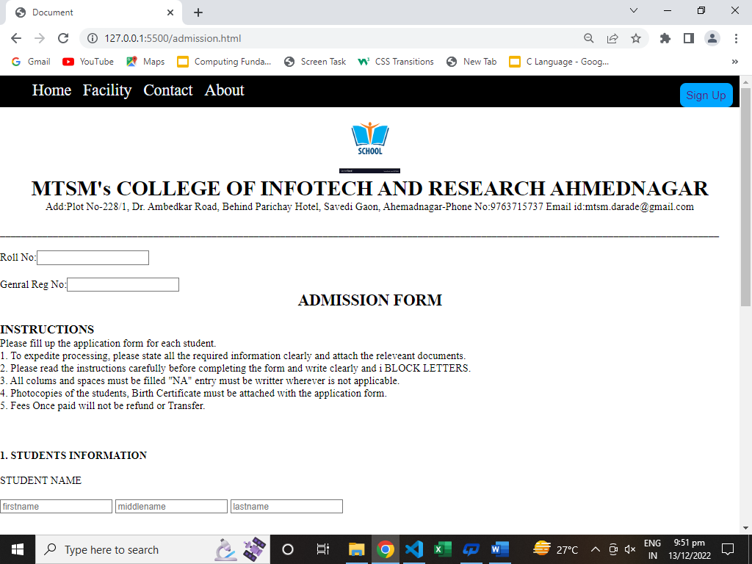

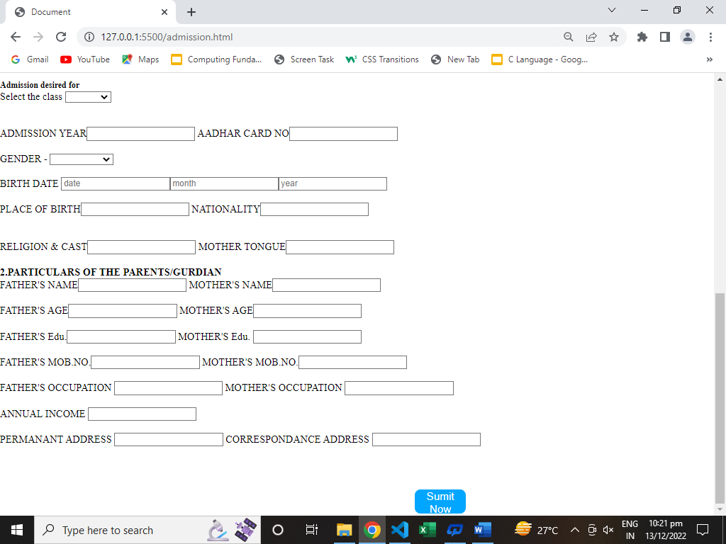

**Chapter-3 Coding:**

**Index.html:**

<!DOCTYPE html>

<html lang="en">

<head>

<meta charset="UTF-8">

<meta http-equiv="X-UA-Compatible" content="IE=edge">

<meta name="viewport" content="width=device-width, initial-scale=1.0">

<title>maharastra college</title>

<link rel="stylesheet" href="css.css">

<link rel="stylesheet" type="text/css" media="only screen and (max-device-width: 480px)" href="css.css" />

<!-- bootsrtrap -->

<link href="https://cdn.jsdelivr.net/npm/bootstrap@5.0.2/dist/css/bootstrap.min.css" rel="stylesheet" integrity="sha384-EVSTQN3/azprG1Anm3QDgpJLIm9Nao0Yz1ztcQTwFspd3yD65VohhpuuCOmLASjC" crossorigin="anonymous">

<script src="https://cdn.jsdelivr.net/npm/bootstrap@5.0.2/dist/js/bootstrap.bundle.min.js" integrity="sha384-MrcW6ZMFYlzcLA8Nl+NtUVF0sA7MsXsP1UyJoMp4YLEuNSfAP+JcXn/tWtIaxVXM" crossorigin="anonymous"></script>

<script src="https://cdn.jsdelivr.net/npm/@popperjs/core@2.9.2/dist/umd/popper.min.js" integrity="sha384-IQsoLXl5PILFhosVNubq5LC7Qb9DXgDA9i+tQ8Zj3iwWAwPtgFTxbJ8NT4GN1R8p" crossorigin="anonymous"></script>

<script src="https://cdn.jsdelivr.net/npm/bootstrap@5.0.2/dist/js/bootstrap.min.js" integrity="sha384-cVKIPhGWiC2Al4u+LWgxfKTRIcfu0JTxR+EQDz/bgldoEyl4H0zUF0QKbrJ0EcQF" crossorigin="anonymous"></script>

</head>

<body>

<div class="nav">

<ul>

<li><a href="index.html">Home</a></li>

<li><a href="facility.html">Facility</a></li>

<li><a href="contact.html">Contact</a>

</li>

<li><a href="about.html">About</a></li>

</ul>

<button class="btn1"><a href="signin.html">Sign Up</a></a></button>

</div>

<div class="container1">

<h1 class="text1">MTSM's COLLEGE OF INFOTECH AND RESEARCH AHMEDNAGAR</h1>

<br>

<center><div class="click here">

<h3 class="text2">For More Information <a class= "link" href="https://www.justdial.com/Ahmednagar/Maharashtra-Public-School-Junior-College-Infront-Of-Dagadi-Kaman-Behind-Hotel-Parichay-Savedi/9999PX241-X241-160505160546-B7E5_BZDET"><button>click here</button></a>

</h3>

<h1 class="text3">B.VOC<BR>(SOFTWARE DEVLOPMENT)</h1>

<span class="ic_phn"></span>

</div>

<br> <br>

<h3 class="text2">For Admission <a class="link" href="admission.html"><button>click hear</button></a></h3>

</div>

</h1>

</div>

</div>

<br><br><br>

</div>

</div>

<div class="container">

<div class="row">

<div class="col">

<div class="card" style="width: 18rem;"></div>

<img src="assets/img/l1.jpg" alt="img not foound" width="400" height="400">

<div class="card-body">

<h5 class="card-title">Computer lab</h5>

<p class="card-text">This lab is the pride of our department. This laboratory consists of advance 15 Dell and Lenovo based workstations

with 20GB Ram and 1 TB Hard disk that are well equipped to meet the

requirements of regular laboratory sessions that are an integral part of the postgraduate curriculum. All workstations have access to

both Linux and Windows platforms. All the required software’s are installed with

antivirus with periodic updates and maintenance of laboratory are at high priority.</p>

</div>

<div class="card" style="width: 18rem;"></div>

<div class="col">

<img src="assets/img/l2.jpg" alt="img not foound" width="400" height="400">

<div class="card-body">

<h5 class="card-title">chemistry lab</h5>

<p class="card-text">The Chemistry Department of MTSM's College, established in 1968, is one of the most versatile, dynamic and largest

department in the college. It caters to the largest number of Junior as well as Degree College students of Science Faculty

and is well-known for its teaching and research accomplishments. The Department is served by a highly qualified, experienced and dedicated teaching

faculty along with efficient co-operative non-teaching staff. Four Faculty members – Dr. Ahamad. M.H. Shaikh, Dr. Julekha Shaikh, Dr. Nilima Dixit and Dr.

Mayuri Joshi are recognized Ph. D guides in Chemistry at the University of Mumbai.</p>

</div>

</div>

</div>

<div class="card" style="width: 18rem;">

<img src="assets/img/phy.jpg" class="card-img-top" alt="img not foound" width="400" height="400">

<div class="card-body">

<h5 class="card-title">Physic lab</h5>

<p class="card-text">The Department of Physics is one of the core Departments of the Science Faculty since the College was established in 1968 and is situated

at the fifth floor of main building of this institution. It has a very well-equipped laboratories for Degree College as well as junior college students.

The Degree College Physics Lab. has an equally equipped dark room attached to it. It also has computers along with the printer and the internet facility.

The laboratories are airy, well-lit and have ample space for storing the instruments used in Physics Practical. The stabilized power supply is provided in the

laboratories. Sufficient number of electrical boards and switches are available in the laboratories for performing electrical, electronics and optics experiments.</p> -->

</div>

</div>

</div>

<div class="info"> <h1>GALLERY</h1></div>

<div class="gallery">

<img src="assets/img/c3.jpg" alt="a" width="175" height="200" onclick="enlargeimg()"id="img1">

<img src="assets/img/c2.jpg" alt="a" width="175" height="200">

<img src="assets/img/l5.jpg" alt="a" width="175" height="200">

<img src="assets/img/6.jpg" alt="a" width="175" height="200">

<img src="assets/img/l4.jpg" alt="a" width="175" height="200">

<img src="assets/img/l3.jpg" alt="a" width="175" height="200">

<img src="assets/img/2.jpg" alt="" width="175" height="200">

<img src="assets/img/3.jpg" alt="" width="175" height="200">

<img src="assets/img/5.jpg" alt="" width="175" height="200">

<img src="assets/img/l6.jpg" alt="" width="175" height="200">

</div>

<div class="info"> <h1>Our students are placed with the following companies</h1></div>

<img src="assets/img/dell.png" alt="" height="100" width="150">&nbsp;&nbsp;&nbsp;&nbsp;&nbsp;&nbsp;&nbsp;&nbsp;&nbsp;&nbsp;&nbsp;&nbsp;&nbsp;&nbsp;&nbsp;&nbsp;

<img src="assets/img/microsoft.png" alt="" height="100" width="150">&nbsp;&nbsp;&nbsp;&nbsp;&nbsp;&nbsp;&nbsp;&nbsp;&nbsp;&nbsp;&nbsp;&nbsp;&nbsp;&nbsp;&nbsp;

<img src="assets/img/amazon.png" alt="" height="100" width="150">&nbsp;&nbsp;&nbsp;&nbsp;&nbsp;&nbsp;&nbsp;&nbsp;&nbsp;&nbsp;&nbsp;&nbsp;&nbsp;&nbsp;&nbsp;&nbsp;

<img src="assets/img/symantec.png" alt="" height="100" width="150">&nbsp;&nbsp;&nbsp;&nbsp;&nbsp;&nbsp;&nbsp;&nbsp;&nbsp;&nbsp;&nbsp;&nbsp;&nbsp;&nbsp;&nbsp;&nbsp;

<img src="assets/img/intel.png" alt="" height="100" width="150">&nbsp;&nbsp;&nbsp;&nbsp;&nbsp;&nbsp;&nbsp;&nbsp;&nbsp;&nbsp;&nbsp;&nbsp;&nbsp;&nbsp;&nbsp;&nbsp;

<img src="assets/img/broadcom.png" alt="" height="100" width="150">&nbsp;&nbsp;&nbsp;&nbsp;&nbsp;&nbsp;&nbsp;&nbsp;&nbsp;&nbsp;&nbsp;&nbsp;&nbsp;&nbsp;&nbsp;&nbsp;

<img src="assets/img/accenture.png" alt="" height="100" width="150">&nbsp;&nbsp;&nbsp;&nbsp;&nbsp;&nbsp;&nbsp;&nbsp;&nbsp;&nbsp;&nbsp;&nbsp;&nbsp;&nbsp;&nbsp;&nbsp;

<img src="assets/img/mcafee.png" alt="" height="100" width="150">&nbsp;&nbsp;&nbsp;&nbsp;&nbsp;&nbsp;&nbsp;&nbsp;&nbsp;&nbsp;&nbsp;&nbsp;&nbsp;&nbsp;&nbsp;&nbsp;&nbsp;&nbsp;&nbsp;&nbsp;&nbsp;&nbsp;&nbsp;&nbsp;&nbsp;&nbsp;&nbsp;&nbsp;&nbsp;

<img src="assets/img/sony.png" alt="" height="100" width="150">&nbsp;&nbsp;&nbsp;&nbsp;&nbsp;&nbsp;&nbsp;&nbsp;&nbsp;&nbsp;&nbsp;&nbsp;&nbsp;&nbsp;&nbsp;&nbsp;&nbsp;&nbsp;&nbsp;&nbsp;&nbsp;&nbsp;&nbsp;&nbsp;&nbsp;

<img src="assets/img/capgemini.png" alt="" height="100" width="150">&nbsp;&nbsp;&nbsp;&nbsp;&nbsp;&nbsp;&nbsp;&nbsp;&nbsp;&nbsp;&nbsp;&nbsp;&nbsp;&nbsp;&nbsp;&nbsp;&nbsp;&nbsp;&nbsp;&nbsp;&nbsp;&nbsp;&nbsp;

<img src="assets/img/deutsche bank.png" alt="" height="100" width="150">

<div class="info"> <h1>ADDRESS</h1>

</div>

<div class="container">

<div class="row">

<div class="col">

<div class="card" style="width: 18rem;">

<div class="maprouter"><div class="gmap_canvas"><iframe class="gmap_iframe" frameborder="0" scrolling="no" marginheight="0" marginwidth="0" src="https://maps.google.com/maps?width=600&amp;height=400&amp;hl=en&amp;q=maharastra college ,savedi&amp;t=&amp;z=14&amp;ie=UTF8&amp;iwloc=B&amp;output=embed"></iframe><a href="https://piratebay-proxys.com/">Piratebay</a></div><style>.mapouter{position:relative;text-align:right;width:00px;height:200px;}.gmap_canvas {overflow:hidden;background:none!important;width:300px;height:200px;}.gmap_iframe {width:300px!important;height:200px!important;}</style></div>

<div class="card-body">

<h2 class="card-title">Maharashtra-Public-School-Junior-College-Infront

-Of-Dagadi-Kaman-Behind-Hotel-Parichay-Savedi,Ahmednagar</h2>

</div>

</div>

</div>

<center>

<tr bgcolor="yellow">

<td colspan="6" align="center">

<p text="black">

copyright &copy; 2022. All Rights Reserved

</p>

</td>

</tr></center>

</body>

</html>

Facility.html:

<!DOCTYPE html>

<html lang="en">

<head>

<meta charset="UTF-8">

<meta http-equiv="X-UA-Compatible" content="IE=edge">

<meta name="viewport" content="width=device-width, initial-scale=1.0">

<title>Document</title>

<link rel="stylesheet" href="css.css">

</head>

<body>

<div class="nav">

<ul>

<button class="btn1">Sign Up</button>

<li><a href="index.html">Home</a></li>

<li><a href="facility.html">Facility</a></li>

<li><a href="contact.html">Contact</a>

</li>

<li><a href="about.html">About</a></li>

</ul>

</div>

<div class="container1">

<h1 class="color1">Facilities</h1>

<br> <br>

<h2 class="color1"> MTSM's COLLEGE OF INFOTECH AND RESEARCH at AHMEDNAGAR is located in Dagadi-Kaman-Behind-Hotel-Parichay-Savedi,Ahmednagar.

The state of the art campus provides for all amenities and facilities for students to make them feel welcome at the campus.

The institute has well furnished and ventilated classrooms with multimedia tools to aid the learning process.

<br> <br>

The classrooms are also equipped with high-speed internet connectivity for interactive learning of students.

Apart from this, Bharati Vidyapeeth Deemed University College of Engineering at Pune facilities also include health services through a hospital, library attached, Computer centre, Auditorium, sports equipment and gym for students to participate in extracurricular activities as well as sports.

Here is some detailed info.</h2>

<br>

<div class="avatars">

<div class="row">

<div class="column">

<img src="assets/img/library.png" alt="Avatar" class="avatar">

<h1>&nbsp; library</h1>

</div>

<div class="column">

<img src="assets/img/sport.jpg" alt="Avatar" class="avatar">

<h1> &nbsp;&nbsp; sports</h1>

</div>

<div class="column">

<img src="assets/img/lptp.png" alt="Avatar" class="avatar">

<h1> Info Tech</h1>

</div>

</div>

</div>

</div>

</body>

</html>

Contact.html:

<!DOCTYPE html>

<html lang="en">

<head>

<meta charset="UTF-8">

<meta http-equiv="X-UA-Compatible" content="IE=edge">

<meta name="viewport" content="width=device-width, initial-scale=1.0">

<title>contact us</title>

<link rel="stylesheet" href="css.css">

</head>

<body>

<div class="nav">

<ul>

<button class="btn1">Sign Up</button>

<li><a href="index.html">Home</a></li>

<li><a href="facility.html">Facility</a></li>

<li><a href="contact.html">Contact</a>

</li>

<li><a href="about.html">About</a></li>

</ul>

</div>

<div class="container1">

<br>

<h1 class="co1">Mailing Address</h1><br>

<h4 class="col2">ADDRESS:228/1, Maharashtra Campus, Savedi, Ahmednagar - 414003, Infront Of Dagadi Kaman, Behind Hotel Parichay</h4> <br>

<h4 class="col2">PHONE NO:9763715737</h4><br>

<h4 class="col2">EMAIL: mtsm.darade@gmail.com</h4><br>

<h1 class="co1">Working Hours</h1><br>

<h4 class="col2">The establishment is functional on<BR>

Monday:- 11 Am- 5 Pm<br>

Tuesday:- 11 Am -5 Pm<br>

Wednesday:- 11 Am -5 Pm<br>

Thursday:- 11 Am -5 Pm<br>

Friday:- 11 Am - 5 Pm<br>

Saturday:- 11 Am - 5 Pm<br>

Sunday:- Closed</h4><br>

<h1 class="co1">GET IN TOUCH WITH US ON SOCIAL MEDIA</h1><br>

<center>

<img class="facebook" src="assets/img/facebook.png" alt="" height="100" width="100">

<img class="instagram" src="assets/img/instagram.png" alt="" height="90" width="80">

<img class="whatsapp" src="assets/img/whatsapp.png" alt="" height="115" width="120">

</center>

</div>

</body>

</html>

signin.html:

<!DOCTYPE html>

<html lang="en">

<head>

<meta charset="UTF-8">

<meta http-equiv="X-UA-Compatible" content="IE=edge">

<meta name="viewport" content="width=device-width, initial-scale=1.0">

<title>sign in</title>

<link rel="stylesheet" href="css.css">

</head>

<body>

<div class="nav">

<ul>

<button href="sign in"class="btn1">Sign Up</a></button>

<li><a href="index.html">Home</a></li>

<li><a href="facility.html">Facility</a></li>

<li><a href="contact.html">Contact</a>

</li>

<li><a href="about.html">About</a></li>

</ul>

</div>

<div class="container1">

<br><br><br><br>

<div class="sign-up-form">

<center> <img class="sign-up-logo" src="assets/img/sign logo.jpeg" alt=""></center>

<center><h1>sign up now</h1></center>

<center> <from>

<input type="email" class="input-box" placeholder="your email">

<input type="password" class="input-box" placeholder="your passward">

<p><span><input type="checkbox"></span> I agree to the terms of services </p>

<button type="button" class="signup-button">sign up</button>

<hr>

<p class="or">or</p>

<button type="button" class="twitter-button">login with twitter</button>

<p>do you have an account ? <a href="sign in"></a></p>

</from></center>

</div>

</div>

</body>

</html>

**admission.html:**

<!DOCTYPE html>

<html lang="en">

<head>

<meta charset="UTF-8">

<meta http-equiv="X-UA-Compatible" content="IE=edge">

<meta name="viewport" content="width=device-width, initial-scale=1.0">

<title>Document</title>

<link rel="stylesheet" href="css.css">

</head>

<body>

<div class="nav">

<ul>

<button class="btn1"><a href="signin.html">Sign Up</a></a></button>

<li><a href="index.html">Home</a></li>

<li><a href="facility.html">Facility</a></li>

<li><a href="contact.html">Contact</a>

</li>

<li><a href="about.html">About</a></li>

</ul>

</div>

<center>

<tr>

<td colspan="6" align="center"><img src="assets/img/logos1.png"height="100">

</td>

</tr>

<!-- <h2>MAHARASTRA COLLEGE OF INFOTECH AND RESEARCH AHMEDNAGAR</h2> -->

<h1> MTSM's COLLEGE OF INFOTECH AND RESEARCH AHMEDNAGAR </h1>

Add:Plot No-228/1, Dr. Ambedkar Road, Behind Parichay Hotel, Savedi Gaon,

Ahemadnagar-Phone No:9763715737 Email id:mtsm.darade@gmail.com

<br><br>

</center>

________________________________________________________________________________________________________________________________________

<br><br>

Roll No:<input type ="number"name"="frame"placeholder="">

<br>

<br>Genral Reg No:<input type ="number"name"="frame"placeholder="">

<br>

<center><h2>ADMISSION FORM</h2></center>

<br>

<h3>INSTRUCTIONS</h3>

Please fill up the application form for each student.

<br>

1. To expedite processing, please state all the required information clearly and attach the releveant documents.

<br>

2. Please read the instructions carefully before completing the form and write clearly and i BLOCK LETTERS.

<br>

3. All colums and spaces must be filled "NA" entry must be writter wherever is not applicable.

<br>

4. Photocopies of the students, Birth Certificate must be attached with the application form.

<br>

5. Fees Once paid will not be refund or Transfer.

<br><br>

<br>

<br>

<h4>1. STUDENTS INFORMATION </h4>

<br>STUDENT NAME

<br><br>

<input type ="text"name"="frame"placeholder="firstname">

<input type ="text"name"="frame"placeholder="middlename">

<input type ="text"name"="frame"placeholder="lastname">

<br><br><br>

<h5>Admission desired for</h5>

Select the class

<select name="cources" id="cources">

<option value=""></option>

<option value="1st std">1st std</option>

<option value="2nd std">2nd std</option>

<option value="3rd std">3rd std</option>

<option value="4th std">4th std</option>

<option value="5th std">5th std</option>

<option value="6th std">6th std</option>

<option value="7th std">7th std</option>

<option value="8th std">8th std</option>

<option value="9th std">9th std</option>

<option value="10th std">10th std</option>

</select>

<br><br>

<br>ADMISSION YEAR<input type ="NUMBER">

<th>

AADHAR CARD NO<input type ="number"></th>

<br><br>

GENDER

-

<select name="genders" id="genders">

<option value=""></option>

<option value="">male</option>

<option value="">female</option>

<option value="">trans gender</option>

</select>

<br><br>

BIRTH DATE

<input type="number" name"="frame"placeholder="date"><input type="number" name"="frame"placeholder="month"><input type="number" name"="frame"placeholder="year">

<br><br>

PLACE OF BIRTH<input type="text">

<th>

NATIONALITY<input type="text">

<br><br></th>

<br>

RELIGION & CAST<input type="text">

</th>

<th>

MOTHER TONGUE<input type="text">

<br><br></th>

<h4>2.PARTICULARS OF THE PARENTS/GURDIAN</h4>

FATHER'S NAME<input type="text">

<th>MOTHER'S NAME<input type="text"></th>

<br><br>

FATHER'S AGE<input type="number">

<th>MOTHER'S AGE<input type="number"></th>

<br><br>

FATHER'S Edu.<input type=" ">

<th>MOTHER'S Edu.

<input type="">

</th>

<br><br>

FATHER'S MOB.NO.<input type="number">

<th>MOTHER'S MOB.NO.<input type="number"></th>

<br><br>

FATHER'S OCCUPATION

<input type=" ">

<th>

MOTHER'S OCCUPATION

<input type=" ">

</th>

<br><br>

ANNUAL INCOME

<input type=" ">

<br><br>

PERMANANT ADDRESS

<input type=" ">

<th>CORRESPONDANCE ADDRESS

<input type=" ">

</th>

<br><br>

<br><br>

<button class="btn1">Sumit Now</button>

</body>

</html>

**about.html:**

<!DOCTYPE html>

<html lang="en">

<head>

<meta charset="UTF-8">

<meta http-equiv="X-UA-Compatible" content="IE=edge">

<meta name="viewport" content="width=, initial-scale=1.0">

<title>About</title>

<link rel="stylesheet" href="css.css">

</head>

<body>

<div class="nav">

<ul>

<button class="btn1">Sign Up</button>

<li><a href="index.html">Home</a></li>

<li><a href="facility.html">Facility</a></li>

<li><a href="contact.html">Contact</a>

</li>

<li><a href="about.html">About</a></li>

</ul>

</div>

<div class="container1">

<br><br>

<h1 class="color1">

Information and details about the

<br> B.Voc (Software Development program)

</h1>

<br><br><br>

<h2 class="color1">

<ul>

Maharashtra college of infotech and research is started in Jun 2010 & registered under the Maharashtra Tantrik Shikshan Mandal Trust in Ahmednagar.

Its a collage in Ahmednagar city,

Bachelor of Vocational Studies in Software Development is a course which usually focuses on a skill development programme which concentrates on both theoretical and practical knowledge

It includes extensive training and practical experience in software development and computer science

This course is made for those students who wish to improve and skills and expertise and earn a decent salaried job.

In this course internship sessions are mandatory in various colleges which collaborates with many recognized industries such as Ashok Leyland etc.

The students are given a real time practical session to improve their skills in the software department

The students are trained with good skills, practical & theoretical knowledge, expertise and experience which helps them for a better future.</h2>

</ul>

</div>

</body>

</html>

**Style.css:**

*

{

margin: 0;

}

.nav {

list-style-type: none;

margin: 100;

padding: 50;

overflow: hidden;

background-color: black;

}

.nav > ul > li {

float: left;

font-size: 24px;

display: block;

padding: 9px;

}

.nav > ul > li > a{

color: aliceblue;

}

.head-top{

height: 50px;

width: 1100px;

margin-left: 99px;

margin-right: 99px;

padding-left: 12px;

padding-right: 12px;

}

.btn1{

background-color: #00a6ff;

height: 37px;

width: 80px;

color: white;

font-size: 17px;

margin-left: 650px;

border: none;

border-radius: 9px;

margin-top: 11px;

}

/* buttun responsive */

/* @media screen and (max-device-width:110px) {

.btn1 {

background-color: #00a6ff;

height: 37px;

width: 80px;

color: white;

font-size: 17px;

border: none;

border-radius: 9px;

margin-top: 11px;

margin-left: 55px

}

} */

.Courses{

font-size: 22px;

}

/* backgrng img */

.container1{

height: 660px;

background-repeat: no-repeat;

background-clip: border-box;

background-size: cover;

background-image: linear-gradient(0deg, rgb(0 0 0 / 50%), rgba(0, 0, 0, 0.8)), url(./assets/img/c1.jpg);

}

.text1{

text-align: center;

padding-top: 65px;

margin-top: 0%;

color: rgb(246, 239, 37);

margin: 0 auto;

/* max-width: 385px; */

line-height: 1.1;

}

.get-started {

margin: 0;

padding: 0;

display: flex;

flex-wrap: nowrap;

max-width: 400px;

justify-content: center;

}

.text2 {

font-size: 26PX;

color: rgb(247, 247, 247);

font-weight: 200;

font-family: Verdana, Geneva, Tahoma, sans-serif;

}

.text2 > a > button{

font-weight: 100;

font-size: 15px;

padding: 8px 8px 8px 8px;

background-color: transparent;

color: rgb(255, 255, 253);

font-family: Verdana, Geneva, Tahoma, sans-serif;

}

.text2 > a > button:hover{

background-color: rgb(103, 103, 102);

}

.text3 {

text-align: center;

padding-top: 65px;

margin-top: 0%;

color: rgb(255, 255, 253);

margin: 0 auto;

/* max-width: 385px; */

line-height: 1.1;

}

.flex {

display: flex;

flex-direction: column;

align-items: flex-start;

max-width: 50vw;

margin: auto;

}

* {

box-sizing: border-box;

}

.column {

float: left;

width: 33.33%;

padding: 4px;

}

button{

cursor: pointer;

}

.img1{

margin-right: 200px;

width: 300px;

height: 400px;

}

.img2{

margin-left: 700px;

width: 300px;

height: 400px;

}

.img3{

margin-right: 500px;

width: 300px;

height: 400px;

}

.flex-container {

display: flex;

flex-direction: column;

/* background-color: black; */

}

.flex-container > div {

width: 56px;

margin: 20px;

text-align: right;

line-height: 75px;

font-size: 50px;

}

.info{

background-color: aqua;

text-align: center;

font-family: Impact, Haettenschweiler, 'Arial Narrow Bold', sans-serif;

}

.maprouter{

margin-top: 18px;

}

.card-body > H2{

padding-top: 8PX;

text-align: center;

font-size: 22PX;

font-family: cursive;

color: blue;

}

.sign-up-form{

width: 300px;

box-shadow: 0 0 3px 0 #00a6ff;

background: #fff;

padding: 20px;

margin: 8% auto 0;

text-align: center;

}

.sign-upfrom h1

{

color: #1c8adb;

margin-bottom: 23px;

}

.input-box{

border-radius: 20px;

padding: 10px;

margin: 10px 0;

width: 100%;

border: 1px solid #999;

outline: none

}

.button{

color: #fff;

width: 100%;

padding: 10px;

border-radius: 20px;

font-size: 15px;

margin: 10px 0;

border: none;

outline: none;

cursor: pointer;

}

.signup-button{

background-color: #1c8adb;

}

.twitter-button{

background-color: #21afde;

}

a

{

text-decoration: none;

}

hr{

margin-top: 20px;

width: 80%;

}

.or{

background: #fff;

width: 30px;

margin: -19px auto 10px;

}

.sign-up-logo{

width: 70px;

}

/* .gallery>img:hover{

width: 500px;

height: 500px;

} */

.avatar {

vertical-align: middle;

width: 120px;

height: 130px;

border-radius: 500%;

margin-left: 500;

}

.color1 {

color: #fff;

text-align: center;

font-weight: 200;

letter-spacing: 2px;

line-height: 1.4;

}

.avatars > .row > .column >.avatar{

margin-left: 5em;

}

.avatars > .row > .column > h1{

color: antiquewhite;

margin-left: 2.2em;

padding-top: 5px;

}

.co1{

font-weight: 600;

font-family: 'Gill Sans', 'Gill Sans MT', Calibri, 'Trebuchet MS', sans-serif;

text-align: center;

color: rgb(252, 248, 248);

/* letter-spacing: 2px; */

line-height: 1.1;

}

.col2{

font-weight: 500;

font-family: Cambria, Cochin, Georgia, Times, 'Times New Roman', serif;

text-align: center;

color: rgb(213, 215, 222);

}

.Facebook{

text-align: center;

margin-left: 100px;

}

.instagram{

margin-left: 100px;

}

.whatsapp{

margin-left: 100px;

}

/* responsive media queriews */

**Chapter 3:**

**Proposed Enhancement:**

Educational website is a full featured website designed specifically for planning

,managing , and scheduling college’s important notices. It is dynamic website

And contains like student login , student application form , faculty, sign up and

admin login to maintain database . It also have quick links like admission procedures

and faculty details . The main objective is user convenience which provides easy user

interface , simple processing , and easy to use website